**Lab 10: Characterization of the MOSFET**

**Faizan Bangash**

**Ecen 325-504**

**November 14, 2018**

**Simulations**

NMOS 2N7000G

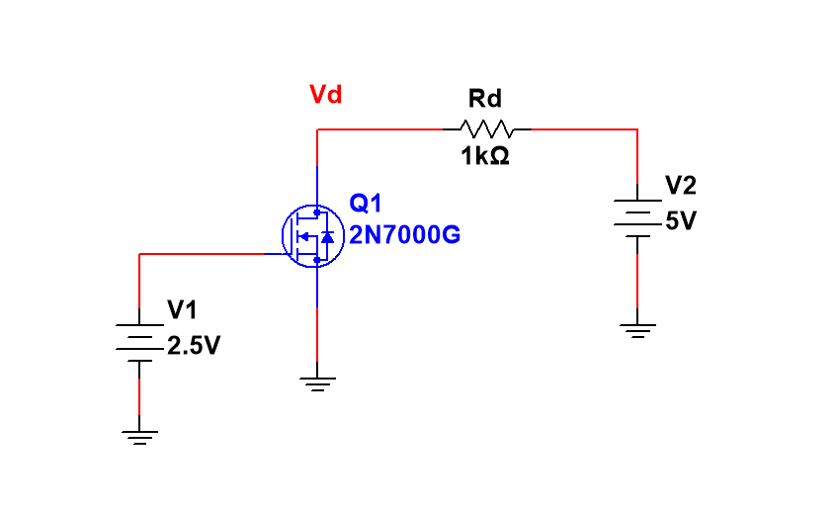

DC sweep

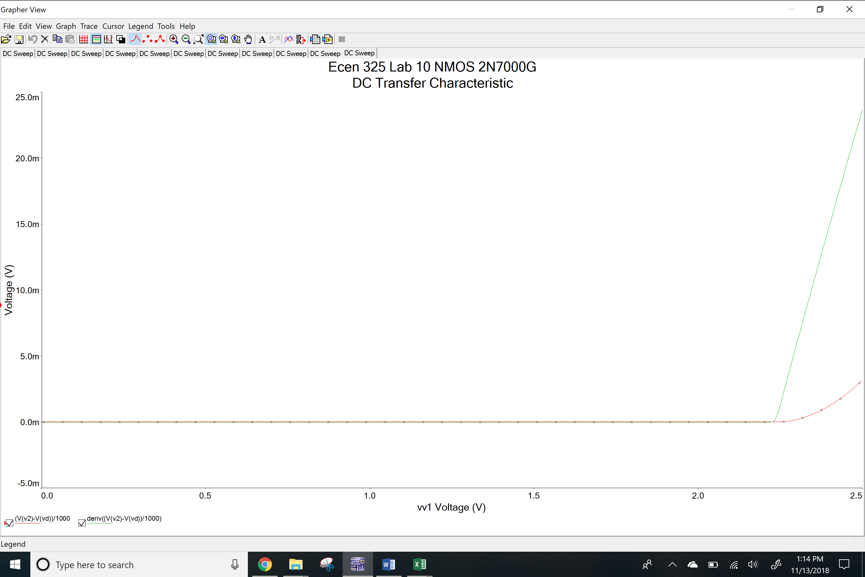

ID vs VGS Plot

ID’ vs VGS Plot

NMOS CD4007N

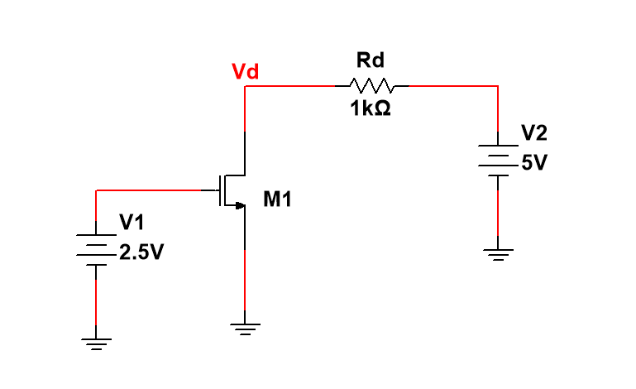

DC Sweep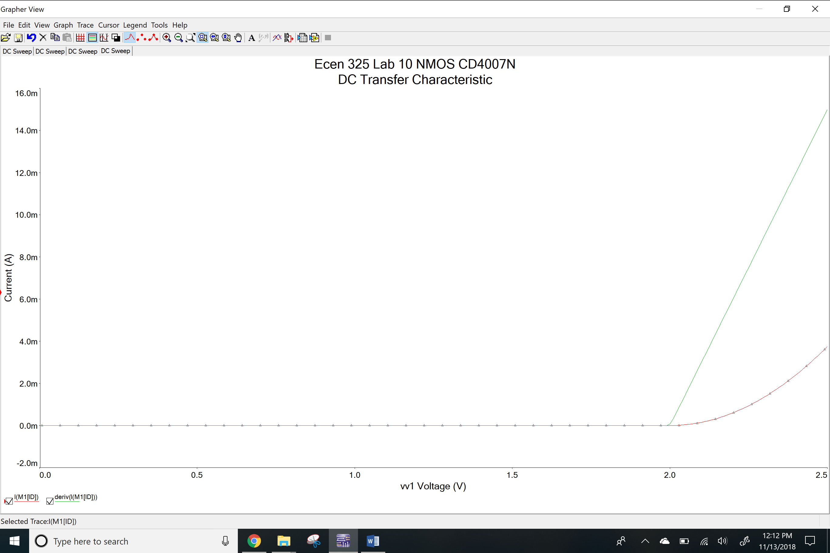

ID vs VGS Plot

ID’ vs VGS Plot

PMOS CD4007P

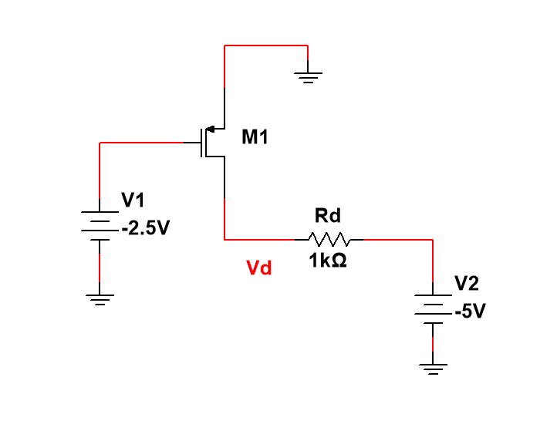

DC Sweep

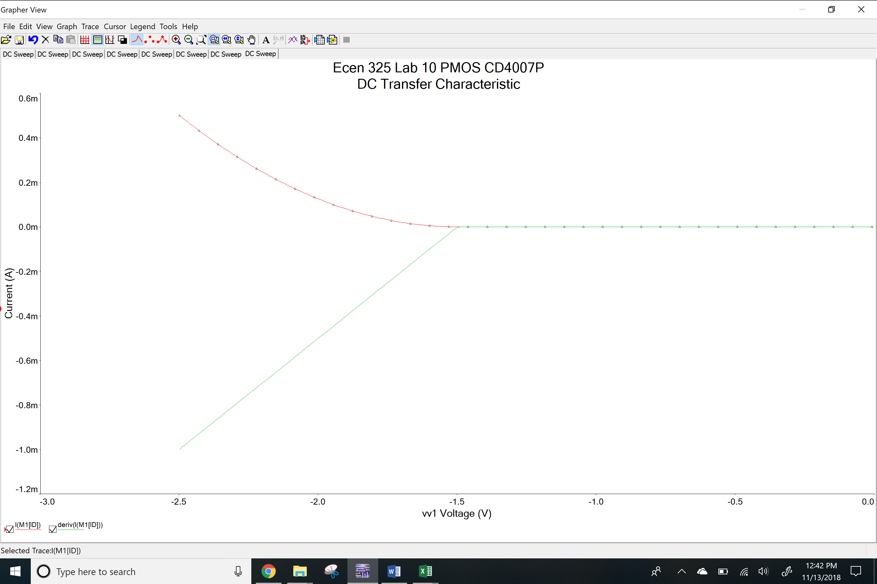

ID vs VGS Plot

ID’ vs VGS Plot

**Measurements**

NMOS 2N7000G

Scope

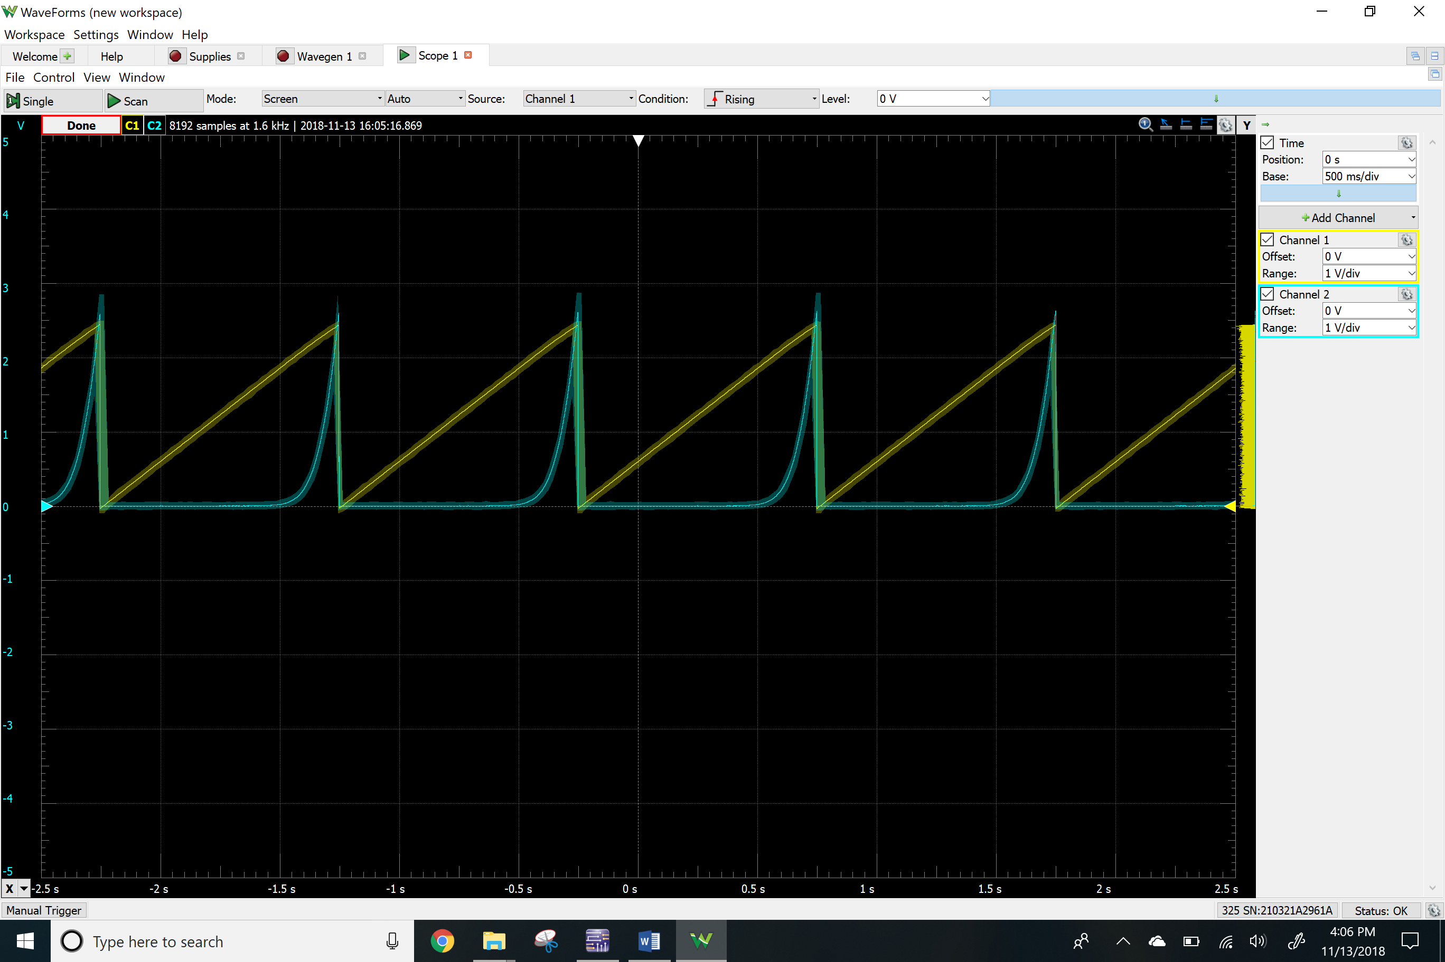

ID vs VGS Plot

ID’ vs VGS Plot

NMOS CD4007N

Scope

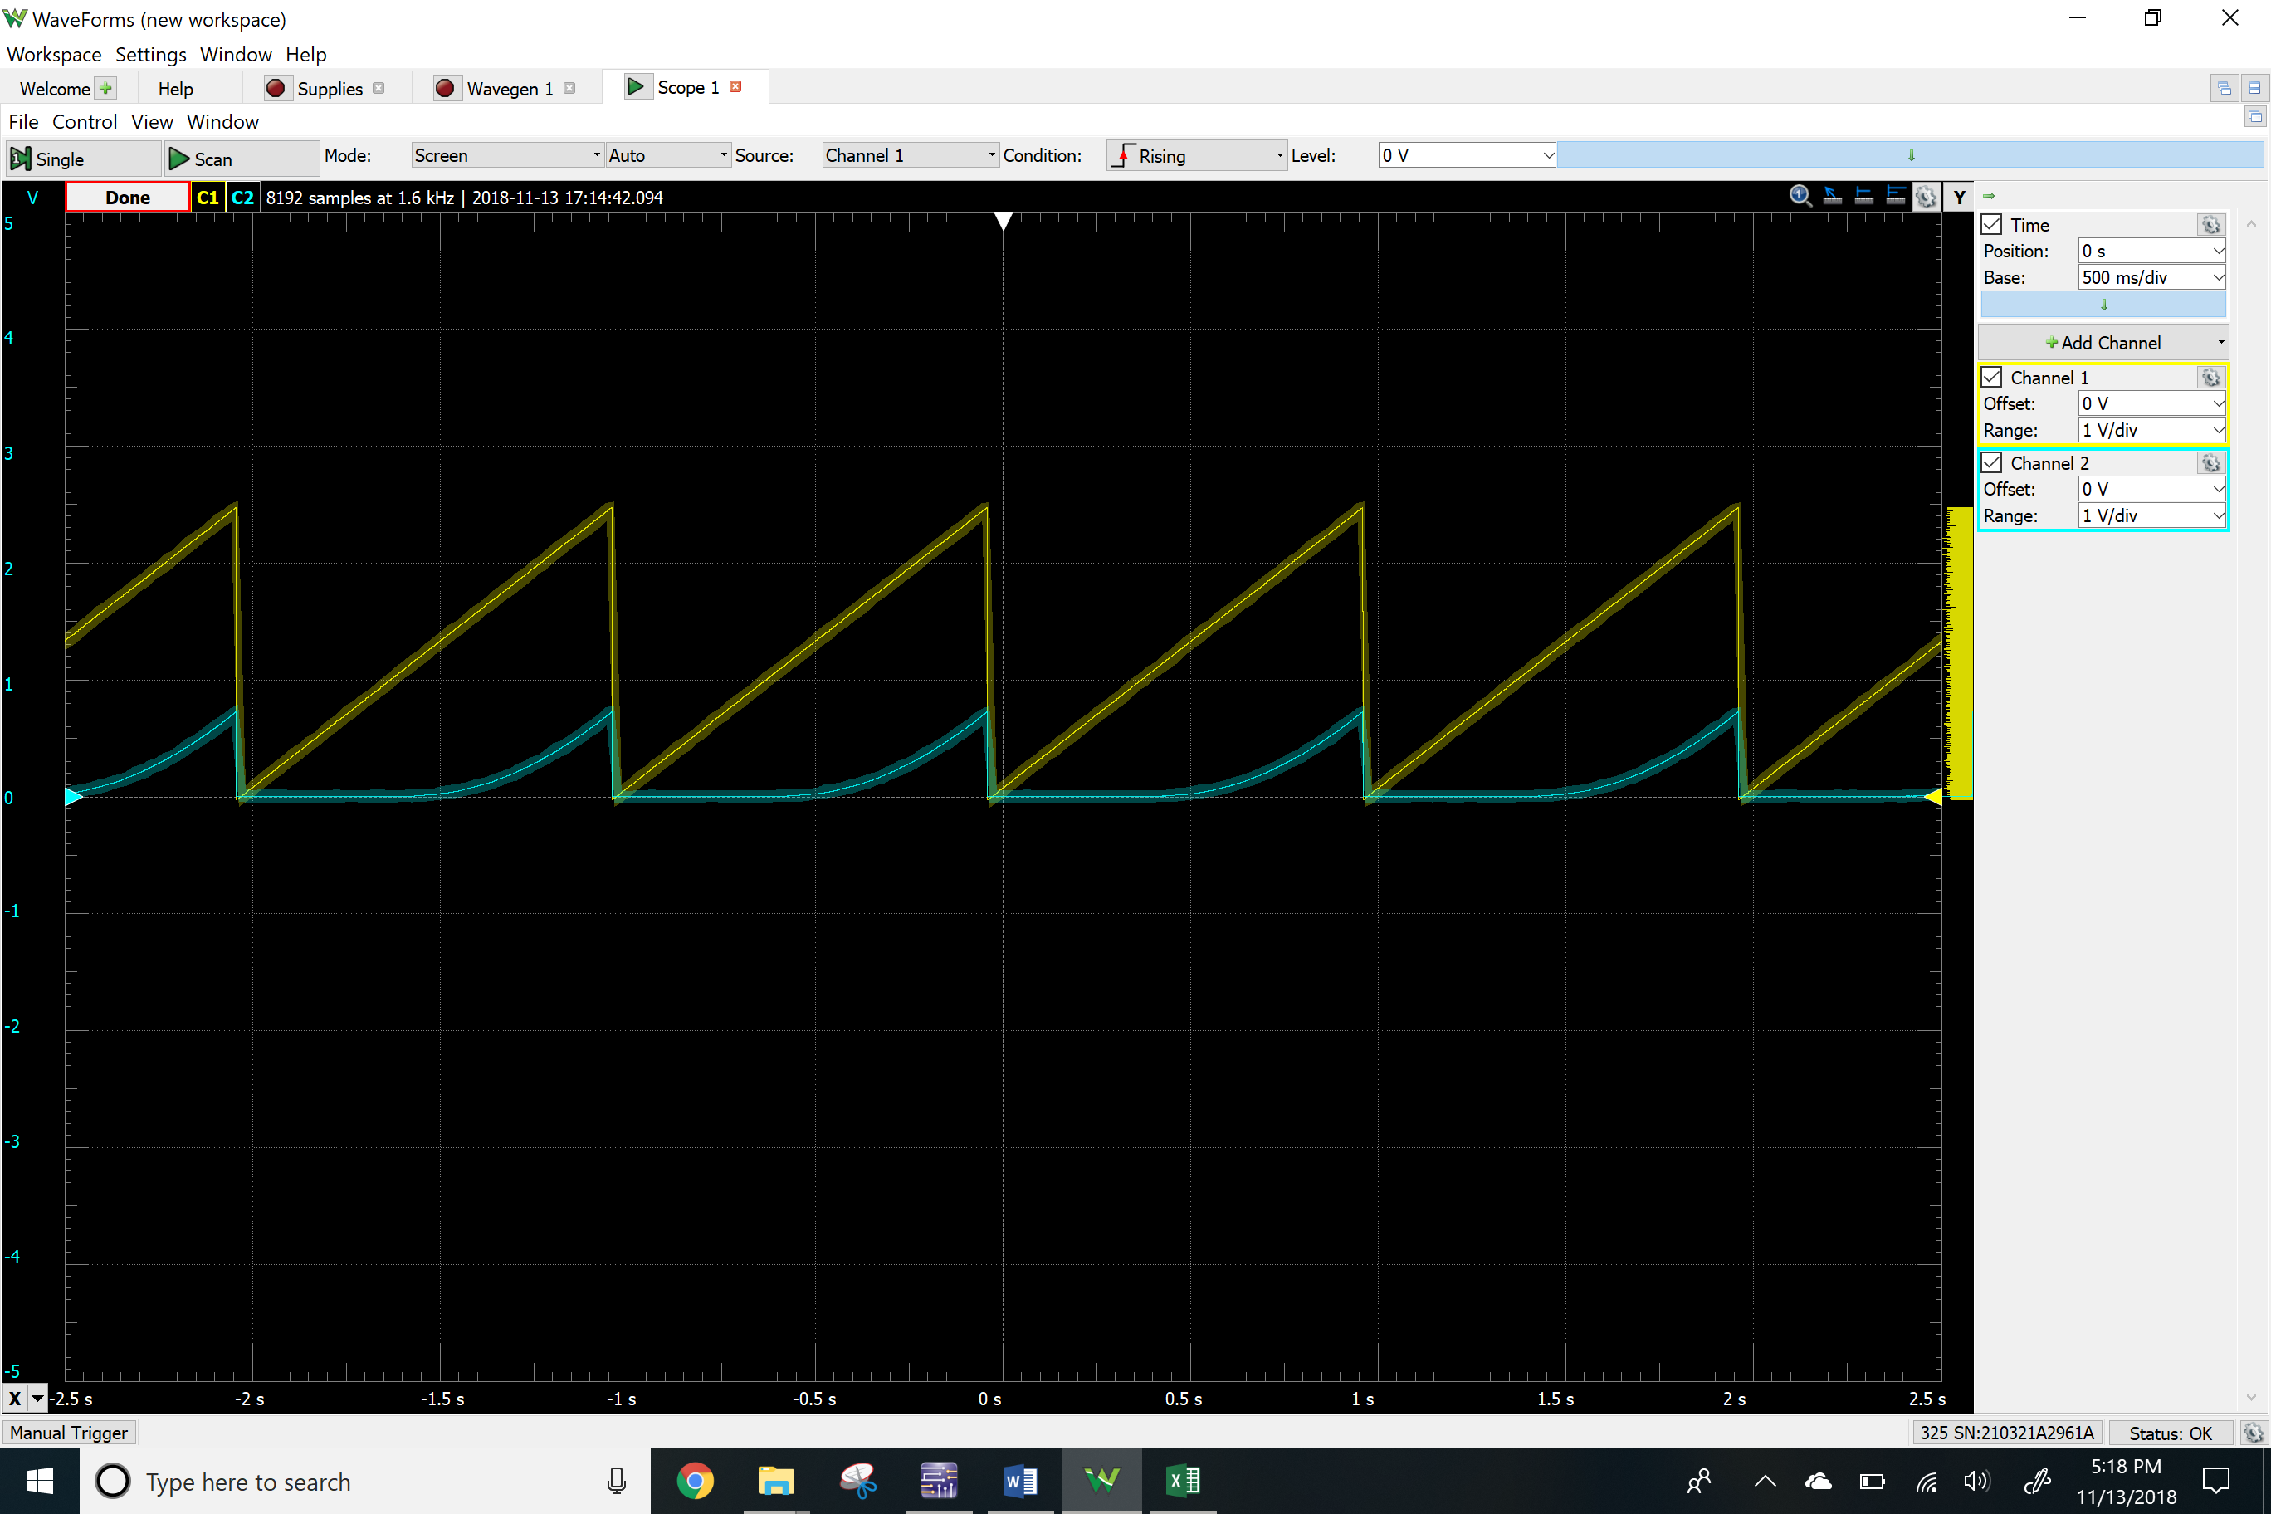ID vs VGS Plot

ID’ vs VGS Plot

PMOS CD4007P

Scope

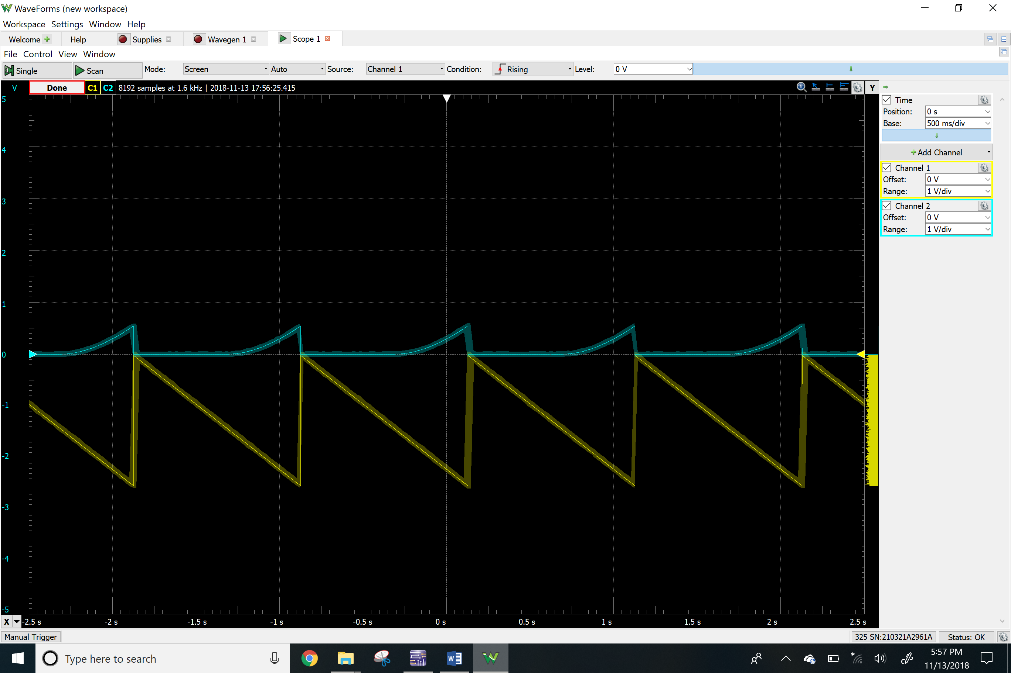

ID vs VSD Plot

ID’ vs VSD Plot

**Results**

Simulations

|  |  |  |  |
| --- | --- | --- | --- |
|  | NMOS 2N7000G | NMOS CD4007N | PMOS CD4007P |
|  | 2.2 V | 2 V | 1.5 V |
|  | 0.0029 | 0.0032 | 0.0004 |

Measurements

|  |  |  |  |
| --- | --- | --- | --- |
|  | NMOS 2N7000G | NMOS CD4007N | PMOS CD4007P |
|  | 2.05 V | 1.12 V | 1.37 V |
|  | 0.032 | 0.0008 | 0.0008 |

**Conclusion**

The purpose of this lab was to understand the basic concepts and the characteristic of MOSFET. I observed the change in drain current and plotted the data by sweeping one voltage and making the other one constant. I calculated the threshold voltage and transconductance using the plot I made from the data. My measurements and simulations numbers don’t match for threshold voltage and transconductance because I simulated this lab using out of data files that were previously sent to us, meanwhile the measurements we made using up to date models. Regardless, the measurement results are more accurate and precise than those of the simulated.